WEEK 15

QUESTION 1

Given an array of integers, reverse the given array in place using an index and loop rather

than a built-in function.

Example

arr = [1, 3, 2, 4, 5]

Return the array [5, 4, 2, 3, 1] which is the reverse of the input array.

Function Description

Complete the function reverseArray in the editor below.

reverseArray has the following parameter(s):

int arr[n]: an array of integers

Return

int[n]: the array in reverse order

Constraints

1 ≤ n ≤ 100

0 < arr[i] ≤ 100

Input Format For Custom Testing

The first line contains an integer, n, the number of elements in arr.

Each line i of the n subsequent lines (where 0 ≤ i < n) contains an integer, arr[i].

Sample Input For Custom Testing

5

1

3

2

4

5

Sample Output

5

4

2

3

1

Explanation

The input array is [1, 3, 2, 4, 5], so the reverse of the input array is [5, 4, 2, 3, 1]

PROGRAM:

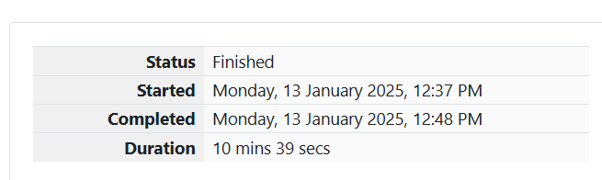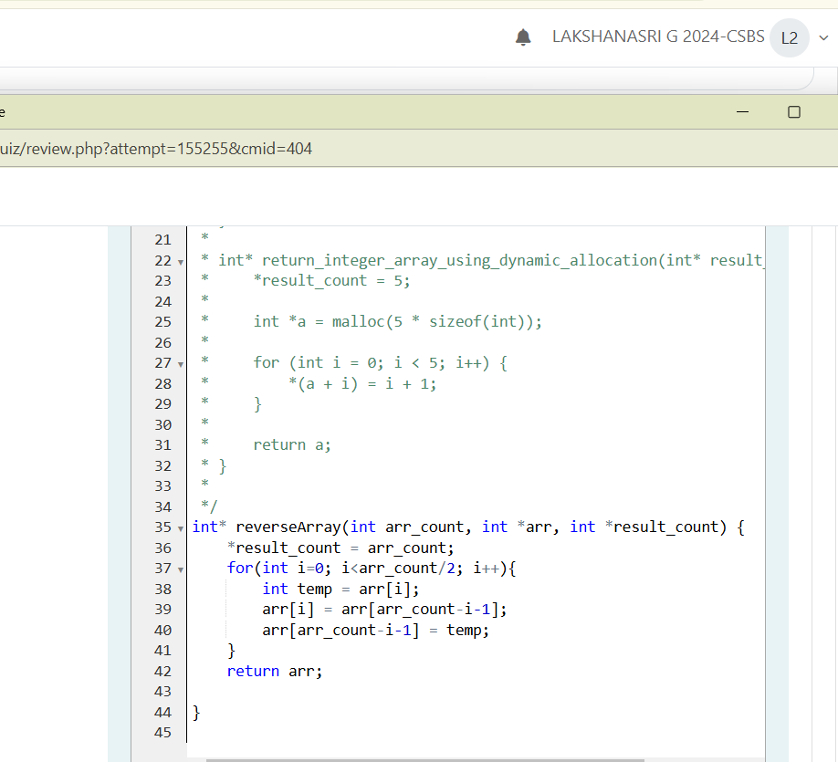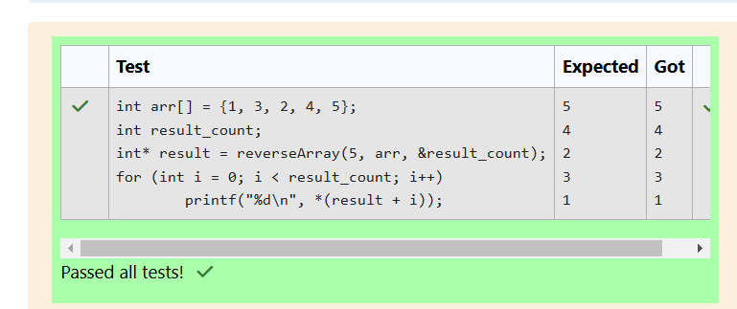

QUESTION 2

Rearrange an array of integers so that the calculated value U is maximized. Among the

arrangements that satisfy that test, choose the array with minimal ordering. The value of U

for an array with n elements is calculated as:

U = arr[1]×arr[2]×(1÷arr[3])×arr[4]×...×arr[n-1] × (1÷arr[n]) if n is odd (or)

U = arr[1]×arr[2]×(1÷arr[3])×arr[4]×...×(1÷arr[n-1]) × arr[n] if n is even

The sequence of operations is the same in either case, but the length of the array, n,

determines whether the calculation ends on arr[n] or (1÷arr[n]). Arrange the elements to

maximize U and the items are in the numerically smallest possible

order.

Example: arr = [5, 7, 9, 21, 34]

To maximize U and minimize the order, arrange the array as [9, 21, 5, 34, 7] so U = 9 × 21

× (1÷5) × 34 × (1÷7) = 183.6. The same U can be achieved using several other orders, e.g.

[21, 9, 7, 34, 5] = 21 × 9 × (1÷7) × 34 × (1÷5) = 183.6, but they are not in the minimal order.

Function Description: Complete the function rearrange in the editor below.

rearrange has the following parameter(s): int arr[n]: an array of integers

Returns:

int[n]: the elements of arr rearranged as described

Constraints: 1 ≤ n ≤ 105, 1 ≤ n ≤ 109

Input Format For Custom Testing: The first line contains an integer, n, the number of

elements in arr. Each line i of the n subsequent lines (where 1 ≤ i ≤ n) contains an integer,

arr[i].

Sample Input For Custom Testing

STDIN

Function

-----

--------

4

→

arr[] size n = 4

1

→

arr = [1, 2, 3, 4]

2

3

4

Sample Output

2

3

1

4

Explanation

U = 2×3×(1÷1)×4 = 24. All other arrangements where U = 24 are numerically higher than

this array, e.g. [2, 3, 1, 4] < [3, 4, 1, 2].

PROGRAM:

